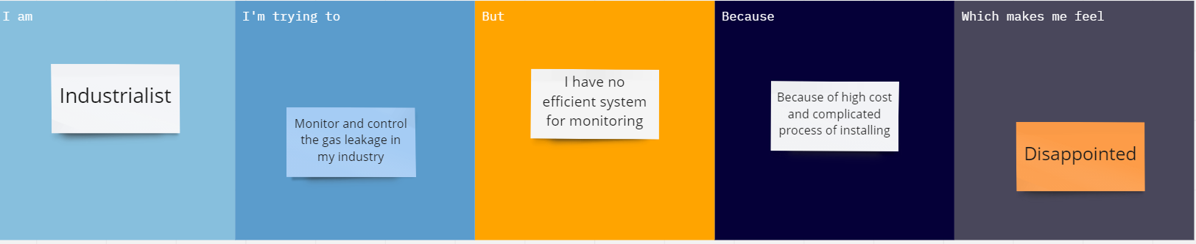
Ideation Phase
Define the Problem Statements

Date | 09/21/22
Team ID | PNT2022TMID16564
Project Name | Gas Leakage Monitoring & Alerting System for Industries
Maximum Marks | 2 Marks

Problem Statement (PS) | I am (Customer) | I am trying to | But | Because | Which makes me feel
PS-1 | Industrialist | Monitor gas leakage in the industry | I don’t have any system for monitoring | The affordable of the system is high and the systems are sometimes making disasters | Unsafe
PS-2 | Industrialist | Control the gas leakage | Also, the installation process is too complicated | The number of sensors is unpredictable and the positioning of equipment is improper | Disastrous

